Identification of location shots … opening credits
The Cardinal
https://www.youtube.com/watch?v=A2bxQZfWvSY

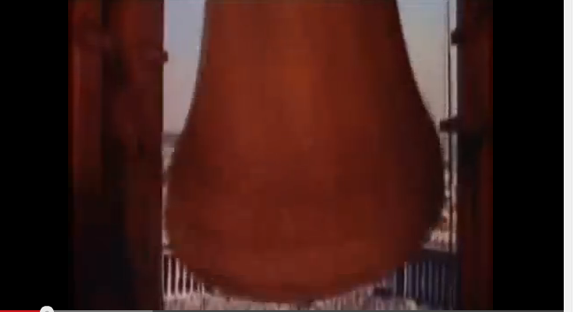
Opening scene: Bells of St. Peter’s and looking out from bell tower onto St Peter’s square (an easy one). Then ….
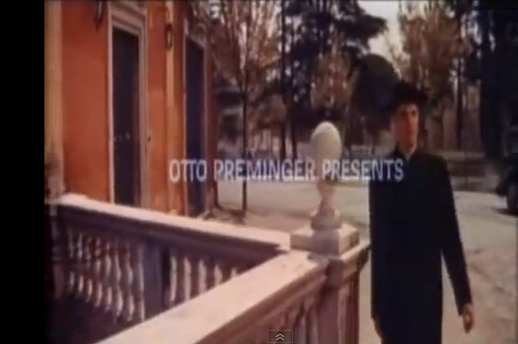
1. Rear door Spanish Academy on the Gianicolo (tomb of Garibaldi in background) walking past Fontana di Paola.
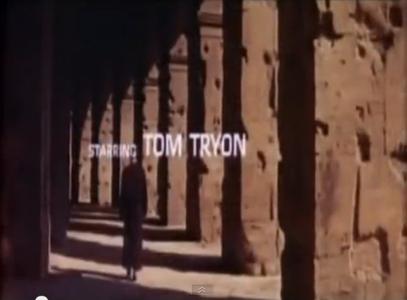
2. Teatro di Marcello (or Terme di Caracalla)
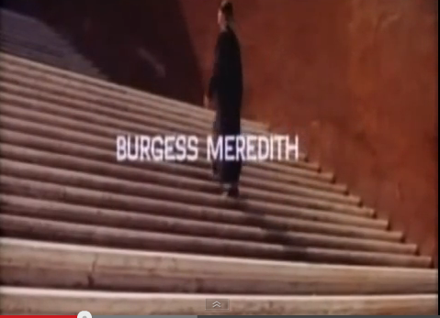
3. Stairs from Via Cavour to San Pietro in Vincoli; per correttezza, I think I’m might be off, here, what do you think?
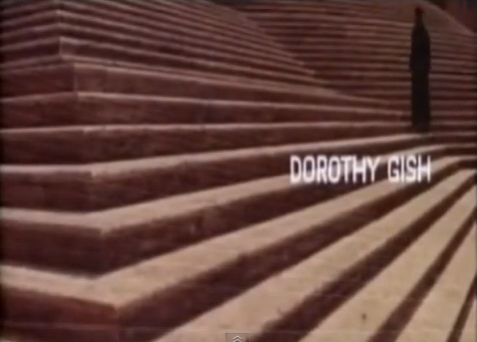
4. Stairs at rear of Santa Maria Maggiore
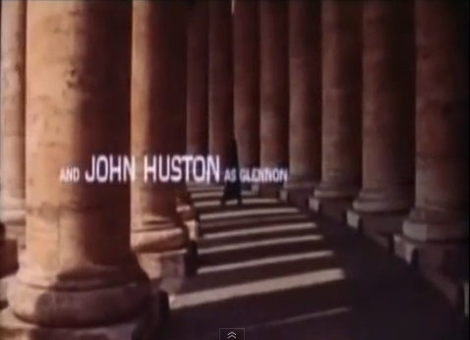
5. Colonnade of San Pietro
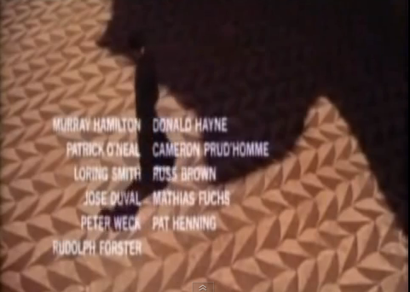
6. Terme di Caracalla (this was after extensive searching on the internet – it’s one the last ones I identified!)
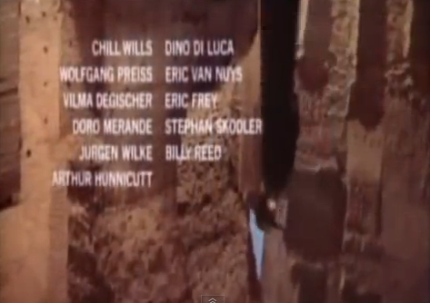
7. I presume Terme di Caracalla
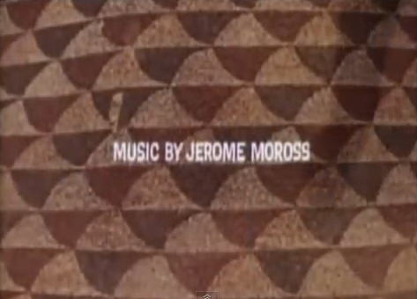
8. Extension of #6
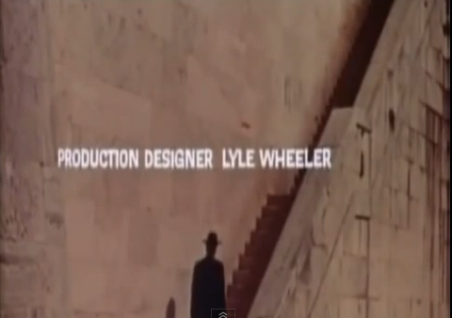
9. From the embankment on the Tiber up to Lungotevere (most likely all’altezza of the Isola Tibertina).
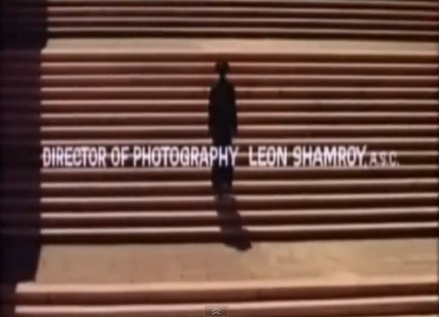
10. This is tough; it may be from the river bank up to the Corso Francia bridge.
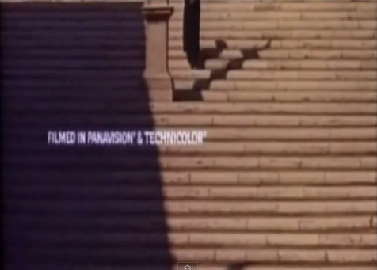
11. Rear of the Piazza del Campidoglio, to the left of the major palazzo in the center – staircase which leads to the Church of the Ara Coeli and the rear of the Vittorio Emmanuele Monument.
This was my most recent find after seeing a photo in La Repubblica
on 5 February 2015 (an anti-mafia demonstration).
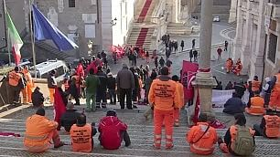

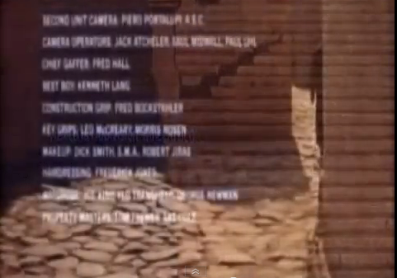
12. Terme di Caracalla
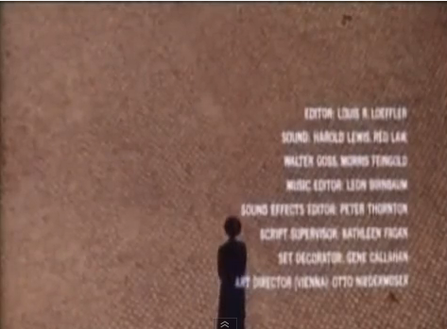
13. Could be a wide sidewalk or any of a number of smaller piazze – it’s a somewhat generic paving smaller than i san pietrini.
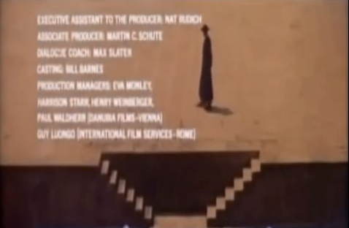
14. Embankment of the Tiber – near Lungotevere Farnese – from Vatican area before Ponte Sisto or on the other side, coming from Vatican, before the bridge at Palazzaccio.
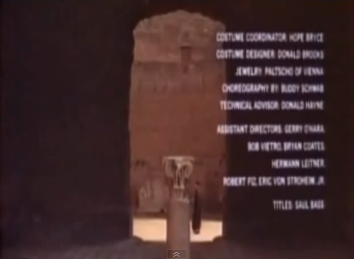
15. Back at the Terme di Caracalla (must have been easy to get filming rights there)
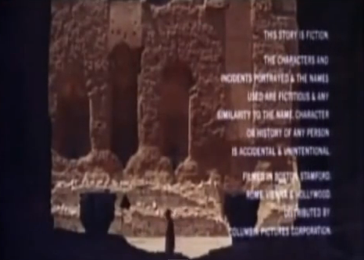
16. Ditto
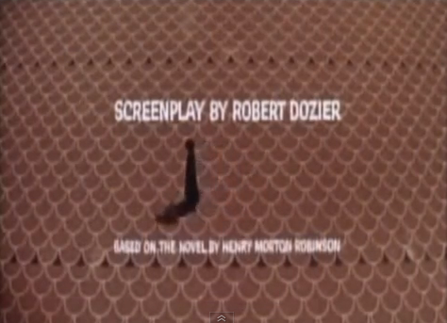
17. (I’m proud of this one) piazza in EUR (please ask me how I found this)
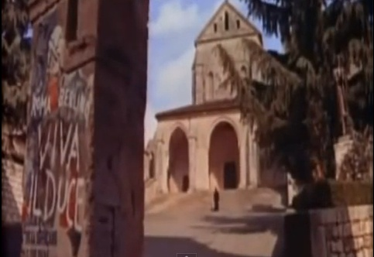
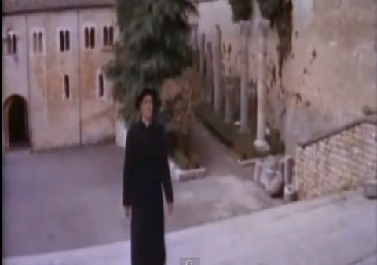
18. Abbazia di Casamari (Cistercense), Veroli, Frosinone, Lazio

